Exercise 1

Develop a Java program that prints all real solutions to the quadratic equation ax2+bx+c = 0. Read in a, b, c and use the quadratic formula. If the discriminate b2-4ac is negative, display a message stating that there are no real solutions.

import java.util.\*;

import java.lang.Math.\*;

public class quadratic

{

public static void main(String args[])

{

Scanner in=new Scanner(System.in);

System.out.println("Enter a");

double a=in.nextDouble();

System.out.println("Enter b");

double b=in.nextDouble();

System.out.println("Enter c");

double c=in.nextDouble();

if(a==0)

{

System.out.println("Invalid inputs\n");

}

else

{

double d=b\*b-4\*a\*c;

if(d>0.0)

{

double r1=(-b+Math.pow(d,0.5)/(2.0\*a));

double r2=(-b+Math.pow(d,0.5)/(2.0\*a));

System.out.println("Roots are real and distinct\n Roots are \n r1="+r1+"and"+r2);

}

else if(d==0.0)

{

double r1=-b/(2\*a);

System.out.println("Roots are real and equal and each root is equal to" +r1);

}

else

{

System.out.println("Roots are imaginary and distinct.\n Roots are\n");

double r1=-b/(2.0\*a);

double r2=(Math.sqrt(Math.abs(d)))/(2.0\*a);

System.out.println("r1="+r1+"+i"+r2+"\n"+"r2="+r1+"-i"+r2);

}

}

}

}

Sample Output

1. Roots are Real and Equal

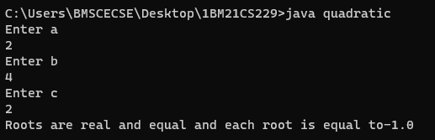

1. Roots are real and distinct

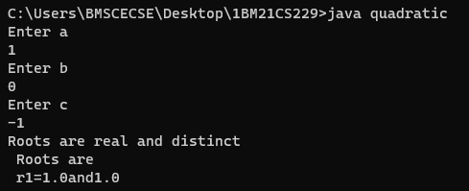

1. Roots are imaginary and distinct

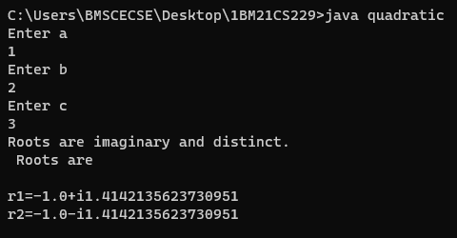

1. Invalid Outputs

